INTRODUCTION:
In many practical situations the dynamic excitation is neither harmonic nor periodic. The dynamic response of single degree of freedom systems to excitations varying arbitrary with time like Step force, Ramp or Linearly increasing force, Step force with finite rise time, Rectangular force and Half Sine pulse force. When a force is applied to a rigid body it changes the momentum of that body.
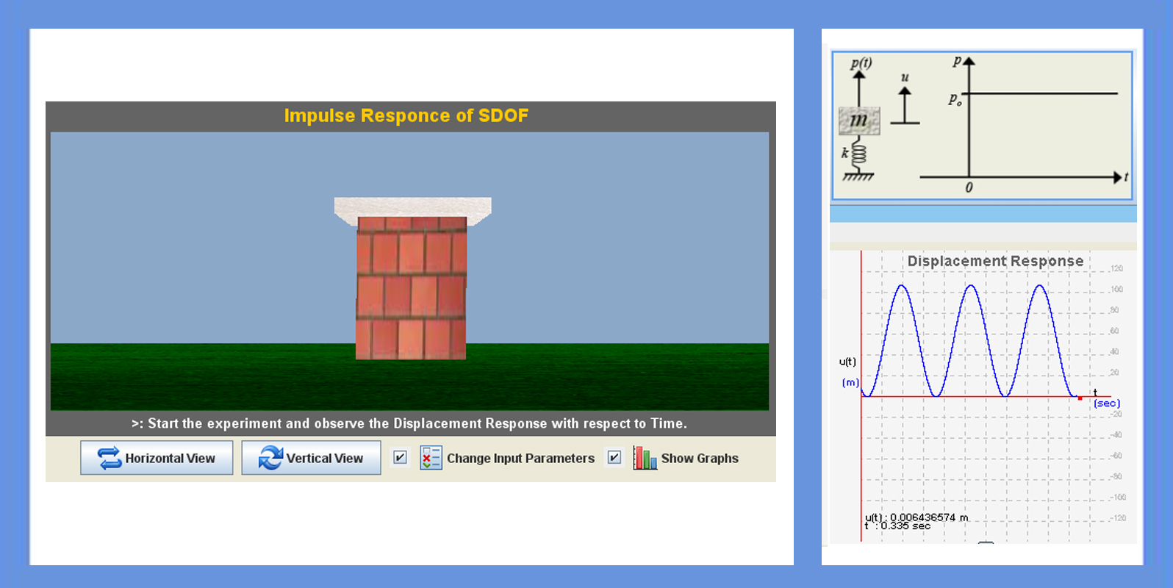
THEORY:

Here 6 types of Impulse forces are considered. They are,

1. Step force:
A step force jumps suddenly from zero to and stays constant at value. It is desired to determine the response of an undamped SDF system. Starting at rest to step force:
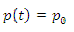
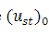
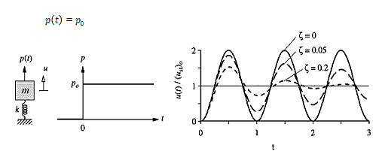
Where = the static deformation due to force

Equation of motion for this step force:

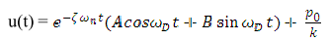
Where

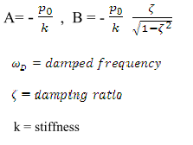
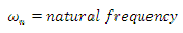

2. Ramp force:

The applied force p(t) increases linearly with time. Naturally, it cannot increase indefinitely, but our interest is confined to the duration where p(t) is still small enough that resulting spring force is within the linearly elastic limit of the spring.
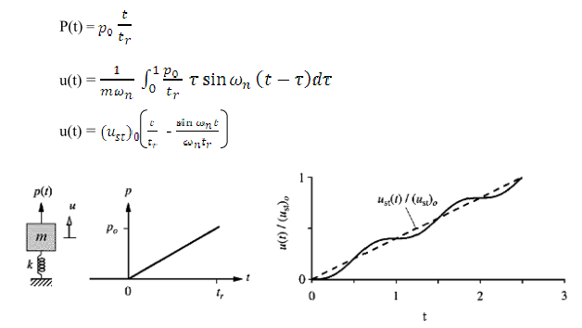
3. Step force with finite rise time:

Since in reality a force can never be applied suddenly. It is of interest to consider a dynamic force that has a finite rise time, , but remains constant thereafter.

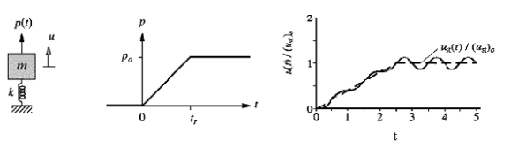
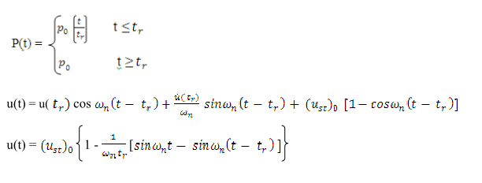
4. Rectangular pulse force:
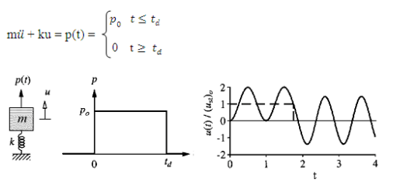
With at-rest initial conditions: u(0) = (0) = 0.The analysis is organized in two phases.

1. Forced vibration phase: During this phase, the system is subjected to a step force. The response of the system is given

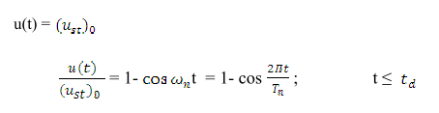
2. Free vibration phase: After the force ends at the system undergoes free vibration, defined by modifying appropriately:

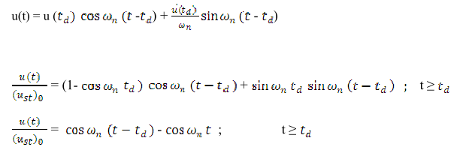

5. Half – cycle sine pulse force: The next pulse we consider is a half-cycle of sinusoidal force. The response analysis procedure for this pulse is the same as developed for rectangle pulse, but the mathematical details become more complicated.
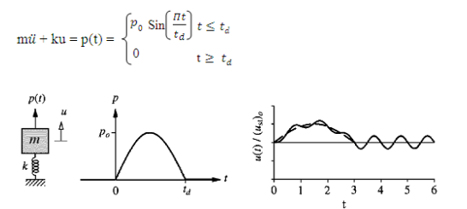
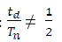
Case 1:

Forced vibration phase: The force is the same as the harmonic force p(t) = sin ωt
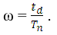
considered earlier with frequency

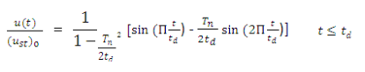
Free vibration phase: After the force pulse ends, the system vibrates freely with its motion.

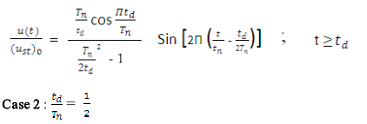

Forced vibration phase: The force is now given by equation
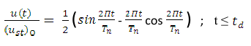
Free vibration Phase: After the force pulse ends at t = free vibration of the
system is initiated by the displacement u and velocity at the end of the force pulse.
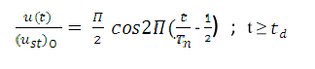

OBJECTIVE:

To determine the response of single degree of freedom system to arbitrary, step and pulse excitations.
MANUAL:
Start the experiment with default values of mass and stiffness of SDOF for 'Step force' type. Total time for the experiment is 10 seconds and drop time is 4 seconds.
Stage 1:
In this stage, user can be allowed to change the type of force and force value along with damping value. Observe the response of SDOF with different types of forces.
Stage 2:
User can change all the dimensions related to mass and stiffness of SDOF along with force type and damping values. Observe the response of SDOF by changing all the parameters.

PART - 2
ANIMATION STEPS
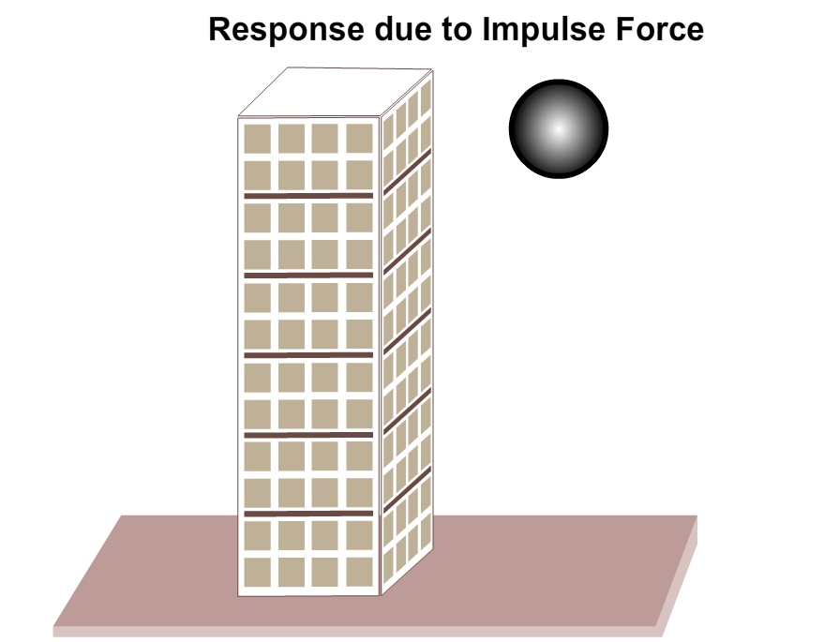

PART – 3
VIRTUAL LAB FRAME
